Ferrari F355 Challenge

Game Overview/Key Features

Game Background

Ferrari F355 Challenge comes to you from the highly acclaimed arcade version renowned for its visuals and realistic car physics. This game will take the player right into the heart of the Ferrari Challenge series, allowing the player to become involved in the passion and emotion of the Ferrari experience, it truly is the most accurate simulation of driving available.

F355 offers amazing depth and a different type of game from the normal arcade racing offering. You will require a great deal of perseverance and skill in order to progress through a very rewarding game. You have a tremendous sense of momentum and weight in turns, a perfectly helpless sense of loss-of-control while spinning, and you feel really glued to the road when you are driving well, there is a great deal of satisfaction to be had when you get it right.

Key Features

The Ferrari Licence – the ultimate car.

Awesome car physics – the most authentic simulation of driving available.

11 stages – Including 6 of the most famous circuits in motorsport.

Exclusive PlayStation®2 enhancements:
- Full Distance replay - complete reproduction of your race from start to finish.
- Enhanced car display - more dynamic camera angles.
- Enhanced Replay Option - displays information normally only seen in Driving Data option, like accelerator, brake and steering wheel.
- Additional car view - outside car viewpoint previously unavailable.
- Improved Visual FX - production quality improved, more tire smoke and clouds of dust.
- Improved Sound FX - more realistic engine sound.
- New grading function – how well did you race, dependent on factors such as navigating corners or bumping other drivers.

Game Modes

There are 4 modes to choose from:

Arcade:

This mode is played just like the arcade version - meet or beat the checkpoint time to progress. Select course, difficulty level and mode –
TRAINING - learn the correct driving line of the course, breaking points and shift timing. DRIVING - drive the course to improve your technique.
RACE - Participate in a race and compete for the top ranking. There is a time limit in each mode and the goal is reached once a number of laps have been completed. There are no continues.

Championship:

Before beginning the race you get the opportunity to test run the track and then adjust car settings depending on how you feel the car has competed. The Race Championship is a total of six races with the number of laps differing from course to course and you must acquire a certain amount of points to stay in the title race. Once a race is completed you can watch the replay and admire your driving form.

Great Driver Challenge

You are evaluated on how skilfully you drive during the race, with points obtained for good race technique. Technical points are awarded for overtaking, utilising another car’s slipstream, and drift around corners. Position points are awarded depending on your final position and Best Lap points are awarded for your fastest lap. Points are deducted for hitting another car, hitting a wall or leaving the track.

The race has a time limit. Pass through the checkpoints within the time allowed to extend the remaining time and continue racing.

There are eight cars in the race and you will start in the last position. Run the set number of laps within the time allowed and exceed a set number of points to clear the course.

Versus Play:

The screen is split vertically and there are two different ways of competing against each other –
VS RACE - The winner is the one in front after a certain amount of laps.
TIME LAG RACE - After passing the checkpoint, race until the loser lags behind a certain time.

Game Stages

11 incredibly challenging real circuits to choose from:
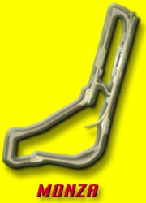
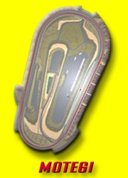
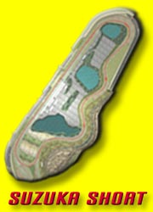
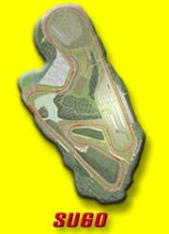
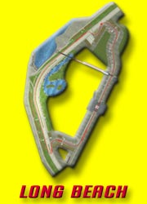
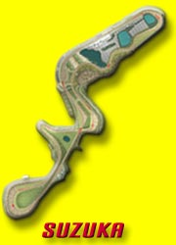

- Motegi: Length - 2.414 miles. This extremely simple layout brings about a super high-speed contest, the maximum bank angle is 10 degrees. The course is more profound than it looks. Pay attention to the 3rd corner, slow down as necessary or you're straight into the wall.

- Suzuka Short: Length - 2.243 miles. Although a short version of the famous Suzuka circuit, don’t take it too lightly, pay attention when entering the final corner from the opposite bank. The difficulty level is high and your times will vary dramatically depending on how you attack the final corner. Needless to say, this is great practice for Suzuka.

- Monza: Length - 5.770 miles. This is a great long distance speed track and there are many opportunities to open out the throttle to the full, unlike all the other courses. Besides the S curve and the two chicanes, it's mostly straight with gentle curves.

- Sugo: Length - 3.704 miles. This track is 70 miles above sea level, but it is comparatively easy if you keep the inclines in mind while driving. The most important aspect is the final corner, as long as you try to plunge into it you can ride on straight speed.

- Suzuka: Length - 5.864 miles. One lap is very long here and there are few areas where mistakes are forgiven because this track is tough. The basic layout is the number 8 crossover made up of a number of various types of corners, making it a very technical course.

- Long Beach: Length - 2.558 miles. High-speed straight-ways, right angled corners and tight hairpins are skilfully combined in Long Beach. It is important to grasp the braking point of the right-angled corner after the long back stretch.

- Atlanta: Length - 1.54 miles. Short laps on a simple, oval shaped circuit. Choosing the correct line around the flat and elevated sections offers a new driving challenge.

- Nürburgring: Length - 2.83 miles. With a reputation as one of the world’s most demanding racetracks, you need to take care after starting each lap of the Nürburgring due to the narrow string of turns which must be traversed almost immediately. This course also includes some nice high-speed corners.

- Laguna Seca: Length - 2.24 miles. A practice lap is essential for Laguna Seca. To the untrained eye, the course might look straightforward, but some of the turns might catch you unawares if you are not fully prepared.

- Sepang: Length: - 3.44 miles. The sprawling Sepang circuit offers two real opportunities to put your foot down. However, this lengthy course also includes some awkward bends which require anticipation and precision to overcome.

- Fiorano Length: 1.85 miles. An official Ferrari test course, Fiorano is a venue where both Ferrari racing cars and road cars are put through their paces. The track was meticulously designed to emulate some of the toughest bends from the world’s race courses.

Game Options

Car Settings:

- You can change the car settings in this mode, the following items can be altered:
- CAR NUMBER, CAR COLOUR.
- RIDE HEIGHT where you can adjust the height of the front and rear ends.
- SPRING where you can increase or decrease the tension in the springs.
- STABILIZER where you can adjust the stiffness of the car's posture.
- CAMBER which adjusts the slanting in the tires from the front of the car.
- TOE which adjusts the slanting in the tires when seen directly from above.
- LSD LOCK RATE, which restricts any difference in drive, torque between the left and right driving wheels.
- WING is the angle of the spoiler, moving it towards one side increases the down force on the rear of the car.

Driving Data:

This option allows you to view any replays you have saved after a race, but in incredible depth. Analyse your performance by studying information such as line, speed, engine speed and shift change on a graph. You can also check records for modes, courses and different level settings.

For more information on SCEE titles, please visit our website
www.playstation.com

Developer: Sega-AM2 Genre: Racing No. of Players: 1-2 Platform: PlayStation®2
Peripherals: Analog Controller (DUALSHOCK®2), Memory Card (8MB) (for PlayStation®2)
Release Date: September 2002

Sony Computer Entertainment Europe Ltd.

Sony Computer Entertainment Europe, based in London, is responsible for the distribution, marketing and sales of PlayStation, PS one and PlayStation 2 software and hardware in 102 territories across Europe, the Middle East, Africa and Oceania. At the end of March 2002, over 36 million PlayStation units had been shipped across these PAL territories, over 89.6 million worldwide. Between its European debut on 24 November 2000 and 5 May 2002, 8.8 million PlayStation2 units have been shipped across the PAL territories, over 30 million world-wide, making it one of the most successful consumer electronic product launches in history.

PlayStation and the PlayStation logo, PS one and PS2 are registered trademarks of Sony Computer Entertainment Inc. All other trademarks are the property of their respective owners.

More information about PlayStation products can be found at http://www.scee.com and http://www.playstation.com .

